

SIMATS ENGINEERING
Saveetha Institute of Medical and Technical Sciences
Chennai 2026
ASSESSMENT TOOL -1
CO3_AT1

Name : P Giriprasad Reddy
Register No : 192525172
Course code : CSA1016
Course name: Software Engineering
Faculty name: Anitadavamani K

Git & Docker Technical Assignment

Safe Route AI: Intelligent Road Hazard Detection and Accident Prevention System

1. PROBLEM ANALYSIS

1.1 Problem Statement
Road accidents can occur due to unexpected road hazards such as potholes, obstacles, pedestrians, vehicles and damaged road surfaces. Traditional road monitoring mainly depends on human observation and may not always provide immediate detection of dangerous conditions.
SafeRoute AI: Intelligent Road Hazard Detection and Accident Prevention System is proposed as an AI-based solution for detecting road hazards from camera-based road images or video. The system processes the input, identifies potential hazards and provides a warning to the user.
The main aim is to support safer driving by providing timely information about detected road hazards.

Basic System Process
Road Camera
↓
Image / Video Input
↓
Image Processing
↓
AI Hazard Detection
↓
Risk Analysis
↓
Warning Generation
↓
User / Driver

1.2 Objectives
- Detect road hazards using AI.
- Process road images or video.
- Identify potentially dangerous objects or conditions.
- Analyze detected hazards.
- Generate warnings for users.
- Provide a simple user interface.
- Maintain detection information.
- Use Git for version control.
- Use Docker for portable deployment.

1.3 Functional Requirements
- Capture road image/video.
- Process input data.
- Detect road hazards.
- Classify detected objects.
- Analyze hazard risk.
- Generate warnings.
- Display results.
- Store detection information.
- Provide backend API communication.
- Run the application using Docker.

1.4 Expected Outcomes
The expected outcome is an intelligent system capable of detecting supported road hazards and providing timely warnings. The project should also demonstrate organized version control and containerized deploymen
2. PROJECT STRUCTURE DESIGN
2.1 Repository Structure
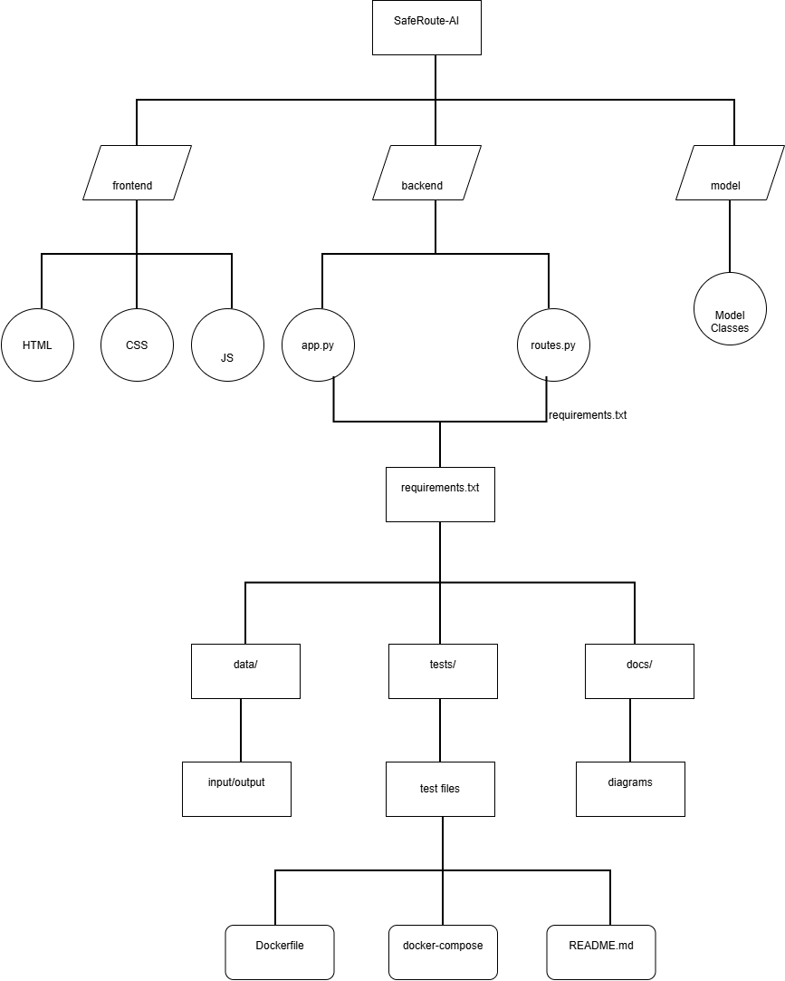

Figure 1 – SafeRoute AI Project Structure
2.2 Folder Explanation
Folder/File | Purpose
frontend | Provides the user interface
backend | Contains API and application logic
model | Stores the AI detection model
data | Stores input and output data
tests | Contains testing files
docs | Stores diagrams and documentation
Dockerfile | Defines the Docker image
docker-compose.yml | Defines application services
.gitignore | Excludes unnecessary files from Git
.dockerignore | Excludes unnecessary files from Docker
README.md | Provides project documentation
requirements.txt | Lists Python dependencies

3. GIT REPOSITORY INITIALIZATION

3.1 Git Initialization
Git is used to manage the SafeRoute AI source code and maintain its development history.
Open the project folder in VS Code and execute:
git init
Check repository status:
git status
Add files:
git add .
Create the first commit:
git commit -m "Initial project setup"
Check commit history:
git log --oneline

3.2 Git Files

.git
The .git directory stores repository information, commit history and configuration.

.gitignore
Prevents unnecessary files such as temporary files, virtual environments and sensitive configuration files from being committed.
Example:
__pycache__/
*.pyc
venv/
.env

README.md

3. GIT REPOSITORY INITIALIZATION

3.1 Git Initialization
Git is used to manage the SafeRoute AI source code and maintain its development history.
Open the project folder in VS Code and execute:
git init
Check repository status:
git status
Add files:
git add .
Create the first commit:
git commit -m "Initial project setup"
Check commit history:
git log --oneline

3.2 Git Files

.git
The .git directory stores repository information, commit history and configuration.

.gitignore
Prevents unnecessary files such as temporary files, virtual environments and sensitive configuration files from being committed.
Example:
__pycache__/
*.pyc
venv/
.env

README.md
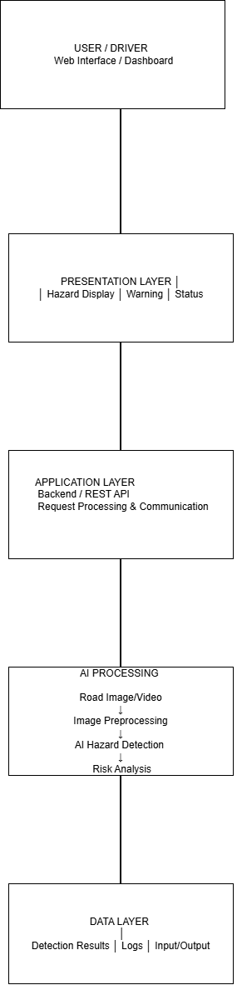

4. GIT BRANCHING STRATEGY AND WORKFLOW

4.1 Branching Strategy
For SafeRoute AI, the following branching model is suitable:
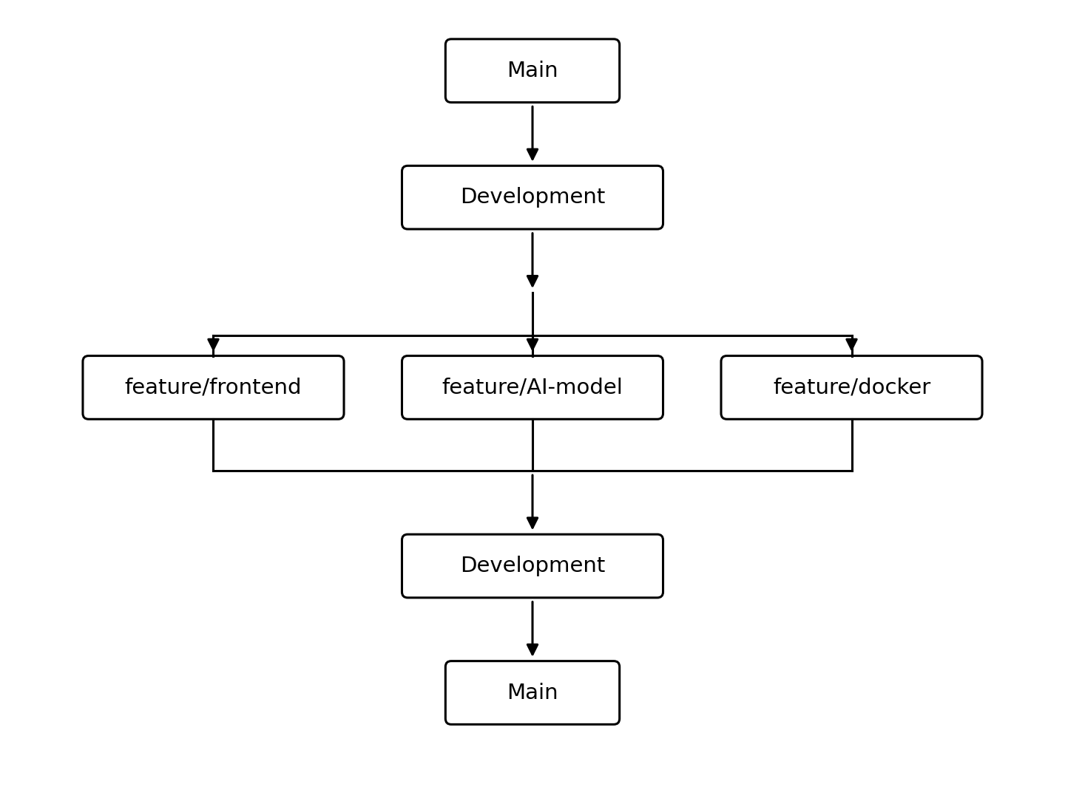

Branches
Main: Stable version of the application.
Development: Integration branch for completed features.
Feature branches: Used for individual functions such as frontend, AI detection and Docker.

4.2 Why This Strategy?
This branching strategy is suitable because SafeRoute AI contains several independent components. Developers can work on different features without directly modifying the stable main branch.

Workflow
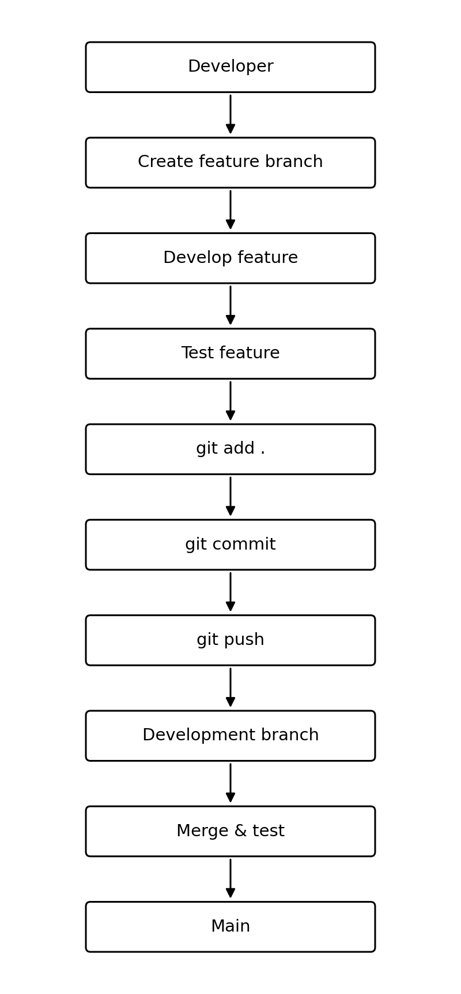

5. COMMIT HISTORY ANALYSIS

5.1 Commit History
SafeRoute AI should use meaningful commit messages.
Example:
Initial project setup
Create SafeRoute AI frontend
Add backend API
Add AI hazard detection
Add risk analysis module
Add Dockerfile
Add Docker Compose configuration
Add testing module
Update documentation
Fix Docker configuration
View the history using:
git log --oneline --graph --all

5.2 Importance of Meaningful Commits
Meaningful commit messages make it easier to understand what changed in the project.
For example:
Good:
Add AI road hazard detection
Poor:
changes
Good commit messages help:
- Track development.
- Identify changes.
- Find errors.
- Maintain the project.
- Roll back changes when necessary.

6. DOCKER ENVIRONMENT DESIGN

6.1 Why Docker?
Docker is used to package SafeRoute AI and its dependencies into a consistent environment.
Docker provides:
- Portability.
- Dependency isolation.
- Consistent execution.
- Easier deployment.
- Easier testing.
- Better maintainability.

6.2 Components to Containerize
The main application components are:
- Frontend
- Backend/API
- AI processing
- Application data

Architecture

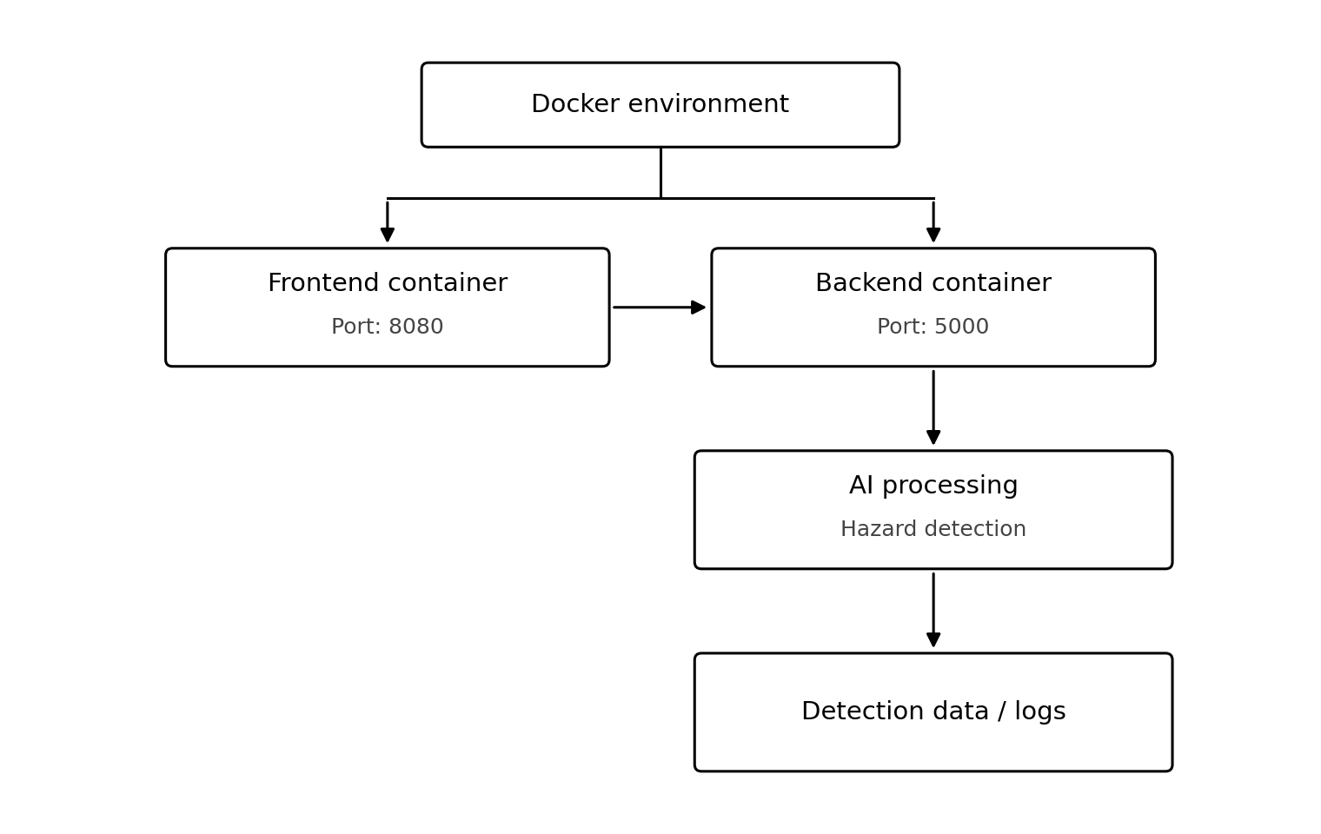Figure 5 – SafeRoute AI Docker Architecture

7. DOCKERFILE DEVELOPMENT
Create a file named:
Dockerfile
Use a suitable Python base image for the backend:
FROM python:3.11-slim

WORKDIR /app

COPY requirements.txt .

RUN pip install --no-cache-dir -r requirements.txt

COPY . .

EXPOSE 5000

CMD ["python", "app.py"]

7.1 Dockerfile Explanation
Instruction | Purpose
FROM | Provides the Python base environment
WORKDIR | Sets the application working directory
COPY | Copies required files
RUN | Installs dependencies
EXPOSE | Defines the application port
CMD | Starts the application

Docker Build Process

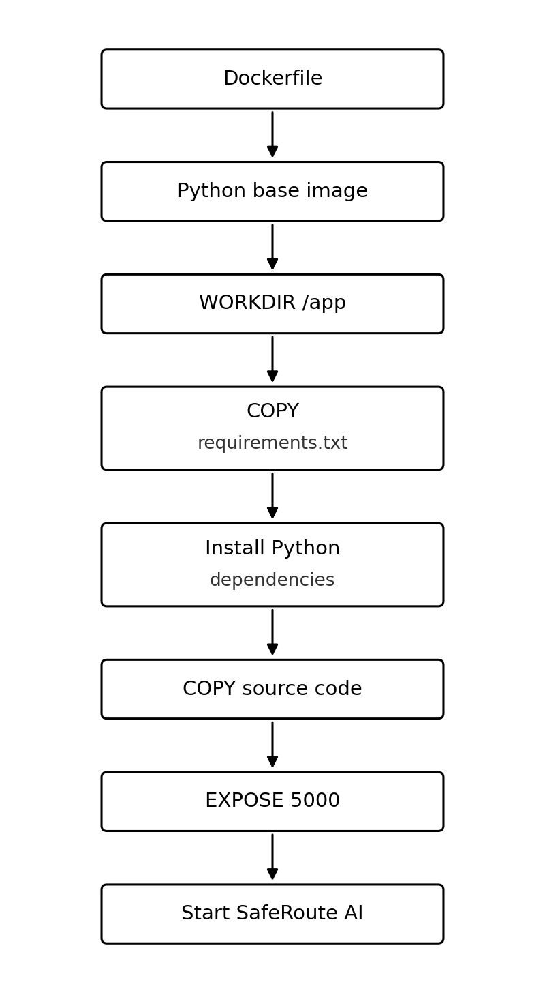

Figure 6 – Dockerfile Build Process

8. DOCKER COMPOSE DESIGN
Create:
docker-compose.yml
Example:
services:

backend:
build: .
container_name: saferoute-backend
ports:
- "5000:5000"
volumes:
- ./data:/app/data
environment:
- APP_ENV=production

frontend:
image: nginx:latest
container_name: saferoute-frontend
ports:
- "8080:80"
depends_on:
- backend

8.1 Services

Backend
Runs the SafeRoute AI application and API.

Frontend
Provides the user interface.

8.2 Ports
Frontend → 8080
Backend → 5000

8.3 Volume
./data:/app/data
Used for application data.

8.4 Environment Variable
APP_ENV=production
Defines the application environment.

8.5 Dependency
The frontend depends on the backend service.

9. CONTAINER DEPLOYMENT AND TESTING

9.1 Build the Application
docker compose build

9.2 Start Containers
docker compose up -d

9.3 Check Containers
docker ps

9.4 View Logs
docker compose logs

9.5 Stop Containers
docker compose down

9.6 Testing Procedure
- Build the Docker image.
- Start the containers.
- Check that containers are running.
- Open the frontend.
- Provide road image/video input.
- Verify AI processing.
- Verify hazard detection.
- Verify warning generation.
- Check stored output/logs.
Testing Flow

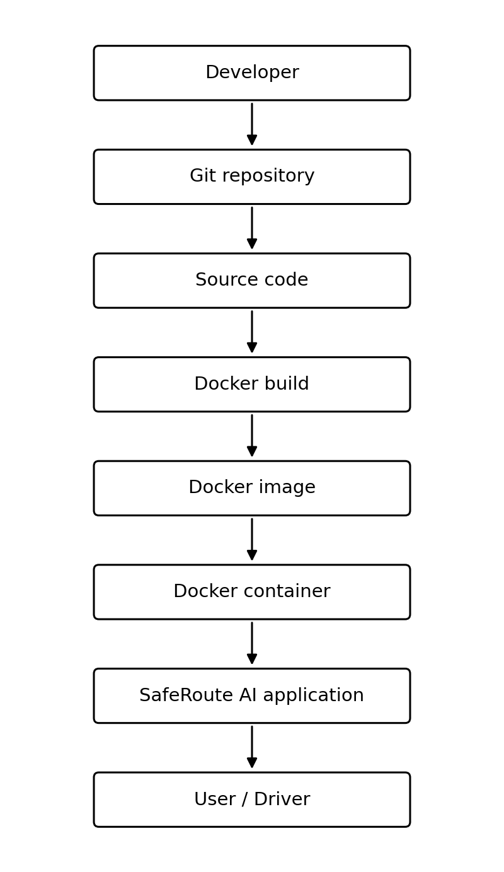

10. BENEFITS, CHALLENGES AND IMPROVEMENTS

10.1 Benefits of Git
Git provides:
- Version management.
- Branch management.
- Collaboration.
- Change tracking.
- Project history.
- Easy rollback.

10.2 Benefits of Docker
Docker provides:
- Portable deployment.
- Consistent environment.
- Dependency isolation.
- Easier testing.
- Easier deployment.
- Scalability.
- Maintainability.
These are the areas specifically requested by the assessment.

10.3 Challenges

Git Challenges
- Merge conflicts.
- Incorrect commits.
- Branch management.

Docker Challenges
- Dependency configuration.
- Port configuration.
- Container communication.
- Large AI model files.

SafeRoute AI Challenges
- Real-time processing requirements.
- Different road conditions.
- Detection accuracy.
- Large image/video data.

10.4 Improvements
Future improvements include:
- Real-time GPS integration.
- Mobile application.
- Cloud deployment.
- Improved AI model.
- Real-time traffic information.
- Weather integration.
- Road hazard history.
- Automatic emergency notification.
- Edge-AI processing.

CONCLUSION AND REFERENCES

Conclusion
SafeRoute AI: Intelligent Road Hazard Detection and Accident Prevention System provides an AI-based approach to identifying potential road hazards and supporting safer driving.
The project combines road hazard detection with software engineering practices. Git is used for version control, branching, collaboration and project history, while Docker provides a consistent and portable environment for application deployment.
The proposed architecture separates the frontend, backend, AI processing and data components, making the system easier to maintain and extend.
Docker Compose further simplifies the management of application services, while structured Git workflows improve project organization and development.
Future enhancements such as GPS, cloud deployment, mobile applications and improved AI models can make SafeRoute AI more suitable for real-world road safety applications.

References
Use references for the actual technologies you implement, such as:
- Git documentation.
- GitHub documentation.
- Docker documentation.
- Docker Compose documentation.
- Python documentation.
- Documentation for the actual AI framework/model used.

